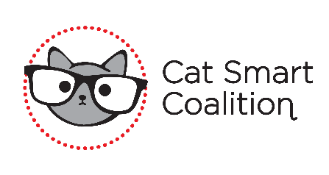
End of Summer 2021 Fundraiser
Primal Brewery Belmont
Saturday, August 28th from 1pm – 5pm
$20 for 20 tickets / $50 for 60 tickets

Prize #1: Weber Grill sponsored by Foils Inc. – Retail Value $379
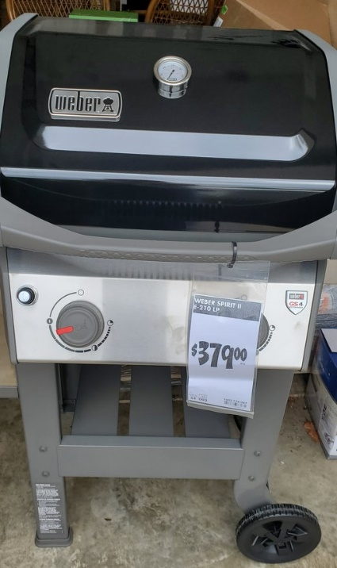

Prize #2: Local Belmont Businesses Bundle – Retail Value $285
- AR Workshop “Life is Better in Belmont” wood sign
- AR Workshop “Home is where my cat is” photo display board
- AR Workshop - $50 Gift Card
- Belmont Yoga – 2 weeks unlimited yoga
- Nellie’s Southern Kitchen - $50 Gift Card
- Mama Poke Bowl - $25 Gift Card
- Cinnaholic - $25 Gift Card

Prize #3: Thought Out Twinkles Jewelry – Retail Value $408
6 one-of-a-kind necklaces: retail $285
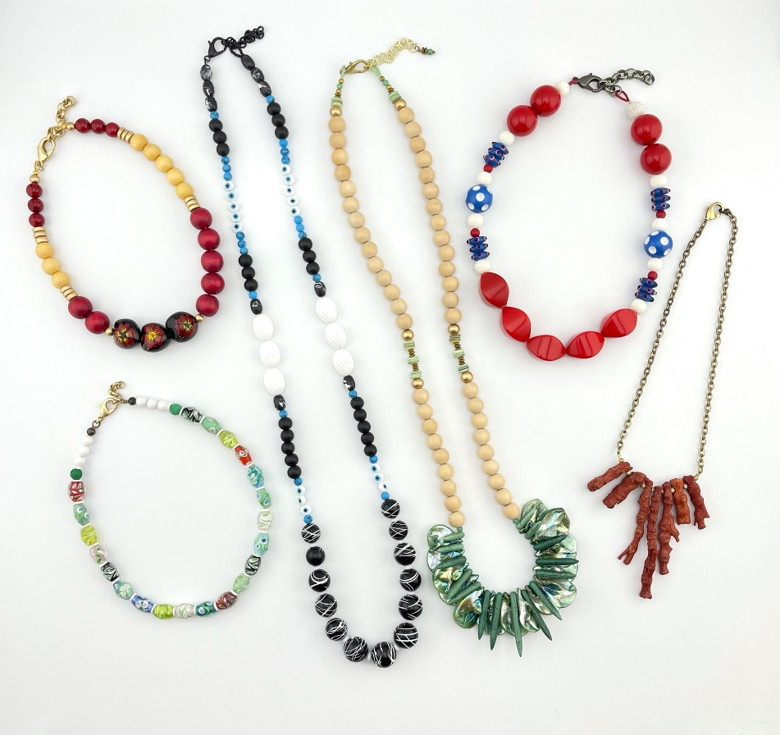
3 pairs of Earrings: retail $44
3 sets of 3 bracelets: $79
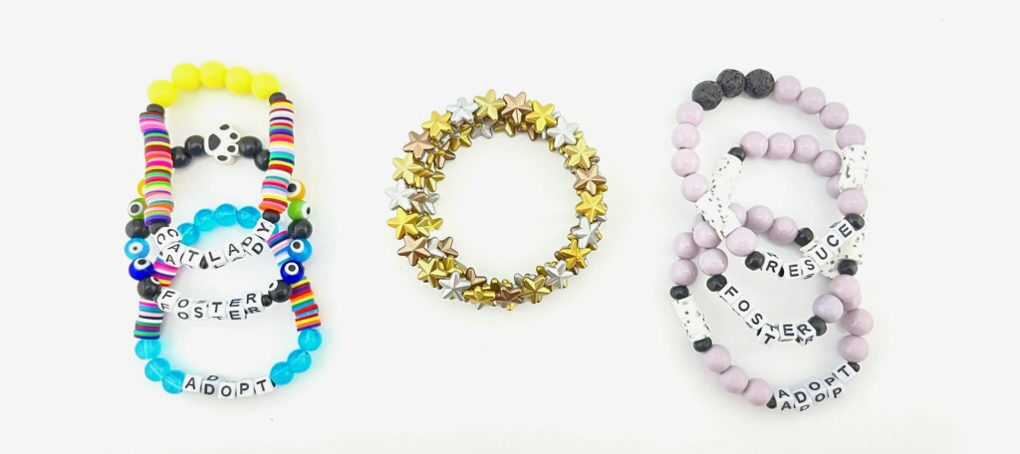

Prize #4: Beer Lovers Bundle – Retail Value $206
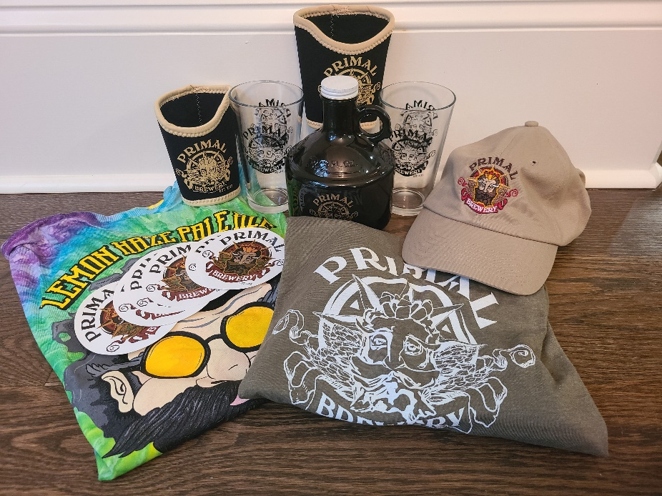
Beer Lovers Raffle Prize Contains:
- Primal Lemon Haze Pale Ale Tee (M)
- Primal Logo Tee (XL)
- Primal adjustable hat
- 2 Primal Pint Glasses
- Primal 32oz Growler
- 2 Primal koozies
- Primal stickers
- $50 Amazon Gift Card
- $50 (2@$25) Primal Gift Card

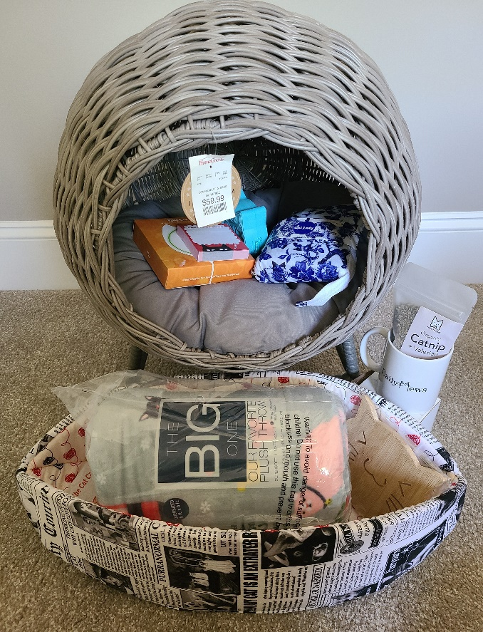
Prize #5: Cat Lovers Bundle – Retail Value $280
Cat Lovers Raffle Prize Contains:
- Daily Mews Coffee Mug
- Premium Organic Catnip
- Cat-themed post-it notes
- The Cat Ball - Cat Canoe
- Round Raised Wicker Cat Bed
- The Big One Cat Themed throw blanket
- $50 Gift Card to Daily Mews
- $50 Amazon Gift Card

Prize #6: 50/50 – Value TBD
The prize amount will be determined after the raffle closes and will be 50% of the money taken in by raffle tickets sold for this specific prize. The other 50% goes to Cat Smart Coalition. All proceeds go towards vetting costs and spay & neuter of community cats

